第一冊上學期期末考(Final Exam.)
姓名：___________
- Identify and fill in the various positions in Chinese.

2. Fill in the blanks with大小多少that describe the amount shown. 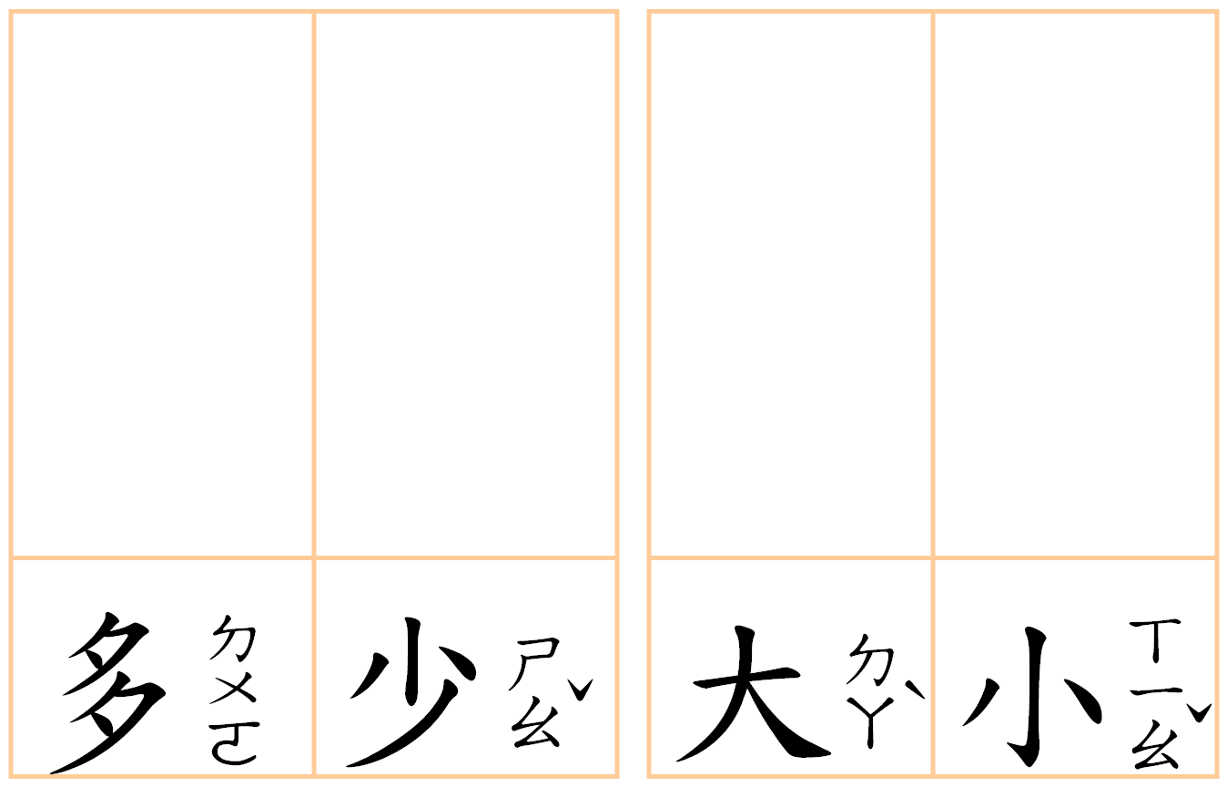

3. Fill in the antonyms.
少
大

水

右

日

上 上

4. Fill in the blanks according to the pictures given.

